**Plan**

1. How to decipher OBI
2. The Earliest Chinese Handbook: an evidence of shamanic code for Gospels (Ancient/precursor)
3. The One in OBI: an evidence of shamanic code for Jesus the Savior
4. The Purpose of OBI: divination, oracle, shamanic spell or prayer

Optical illusion

Within visual perception, optical Illusion (also called a visual illusion) is a type of illusion that plays tricks on human vision system, which requires the eyes and brain work together to function and look at different perceptions.

Optical illusions happen when your brain struggles to connect what it’s seeing with what it expects to see.

 In one-tenth of a second, your visual system sees, transmits, and processes images. Your brain strives to organize this information by defining borders, analyzing contrasting areas, sorting colors, and even guessing, based on experience, what is needed to fill the blanks. It’s constantly predicting what will happen next, which is its way of protecting you.

This process usually works, but sometimes your brain gets confused and can’t logically assemble this information. The result? An optical illusion.

Brain Teasers require an unconventional way of thinking, however, sometimes it also involves an excellent qualitative and quantitative approach. In contrast to the above image, you must use your quantitative sharpness and cognitive skills to solve this picture puzzle. Although it is really simple, you just need to rack your brain looking for the quickest way to solve this and try and find a brain teaser.

There are various types of Optical illusions, including physical, physiological, and cognitive illusions, which have Ambiguities, distortions, paradoxes, and fictions in each class. An optical illusion is a mind-bending illustration of an entity, drawing, or image with distinct impressions if glanced at from different perspectives. It helps us test our brain and optical power by finding different illusions.

The internal relationship among huge number of obc is not easily visible to most people as it needs some degree of an optical illusion genius.

practicing optical illusions through well designed programs has advantages to sharpen eyes quickly Puzzles, artworks, brainteasers, and visual illusions are all examples of optical illusion practices.

Optical illusions make obc research fascinating because they challenge our capacity for seeing what regular people cannot see. Additionally, it offers important insights into how optical illusions affect the human brain and faith.

Like hallucinations, though, **illusions are not necessarily a sign of a psychiatric condition**, and anyone might experience them. They can occur for many reasons, such as the effect of light on an object, insufficient sensory information about an object, or errors in an individual's processing of sensory details.

These illusions are caused by your brain’s misinterpretation of images. Your perception of an illusion is more dependent on how your brain processes information than how your eyes present that information. Find out what optical illusions are and what makes them so baffling:

One of special features of the OBC that differs to the modern brainteasing pictures is that OBC is an optical illusion to look alike multiple different objects but that share a common theme. For example, the Chou, can be viewed as a nailed hand, a rising man, a cross – three images are cohesively parts of the central theme of the sacred Handbook.

Optical Illusion or visual Illusion is an illusion caused by the visual system. It is characterized by a visual perception that appears to differ from reality. In other terms, Optical Illusion is a visual deception where we get deceived by what we see or misunderstand the thing we saw. Optical Illusion deceives and confuses people by playing with color, light, and patterns.

Optical Illusion or visual Illusion is an illusion caused by the human visual system. It is characterized by a visual perception that the observers with different thinking see the images differently. It is a case that demonstrates “what you believe determine what you see” which is opposite to “seeing is believing”

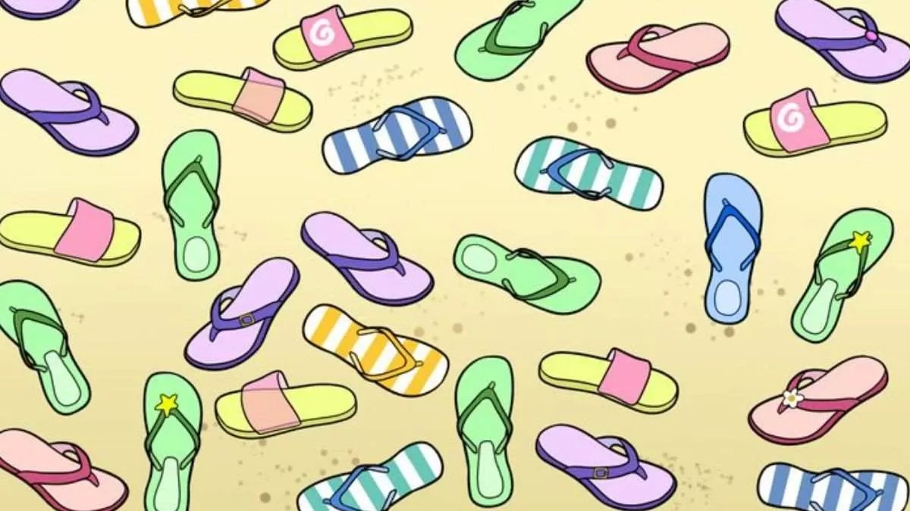

# Brain Teaser for IQ Test: Can you spot the Slipper with no pair in picture within 13 secs?

# <https://www.jagranjosh.com/general-knowledge/brain-teaser-iq-test-can-you-spot-the-slipper-with-no-pair-in-picture-1678950061-1>

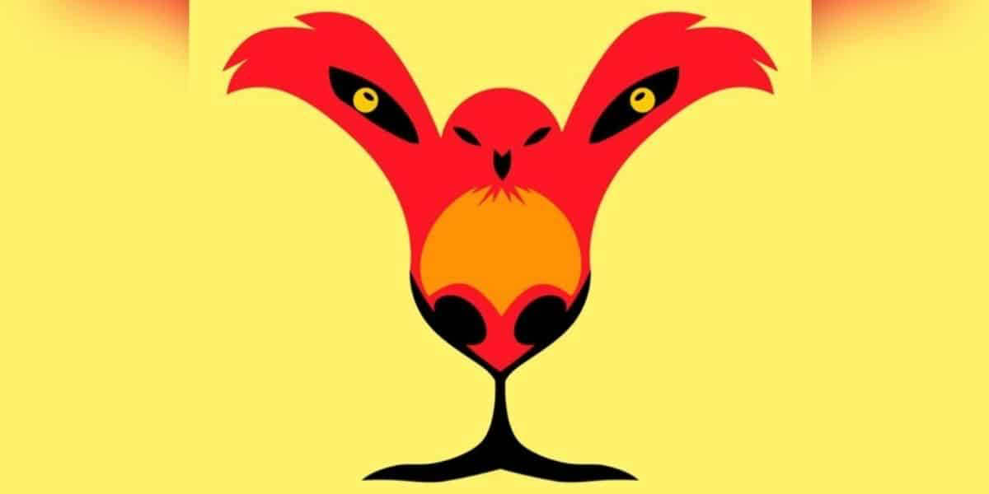

Personality test: What you see first reveal your hidden strength. Ready to explore it?

<https://abmeyerwood.com/personality-test-what-you-see-first-reveal-your-hidden-strength-ready-to-explore-it/>

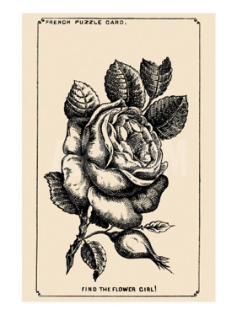

the Girl’s face hidden in the Rose

<https://www.jagranjosh.com/general-knowledge/1880s-optical-illusion-to-test-your-brain-can-you-spot-girls-face-hidden-in-rose-1661513162-1>

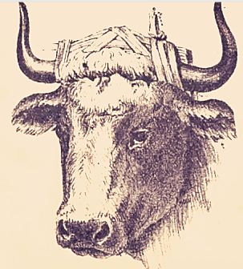

Bull Master’s Hidden Face

<https://www.jagranjosh.com/general-knowledge/optical-illusion-iq-test-only-a-genius-can-spot-bull-masters-hidden-face-1662461885-1>

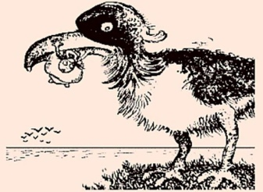

a Man catching Fish inside Giant Bird

<https://www.jagranjosh.com/general-knowledge/century-old-optical-illusion-people-with-high-iq-can-spot-man-catching-fish-inside-giant-bird-1662719345-1>

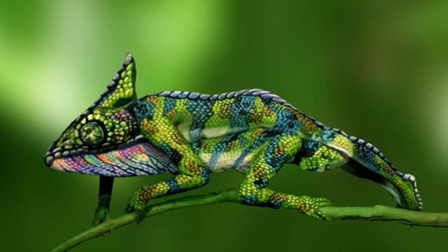

Find Two Hidden Women in 9 seconds

<https://www.jagranjosh.com/general-knowledge/can-you-spot-the-two-hidden-women-in-this-optical-illusion-within-9-seconds-1661524548-1>

 Circus Master’s Elephant Hidden in Picture

<https://www.jagranjosh.com/general-knowledge/iq-test-optical-illusion-can-you-spot-circus-masters-elephant-hidden-in-picture-1662374911-1>

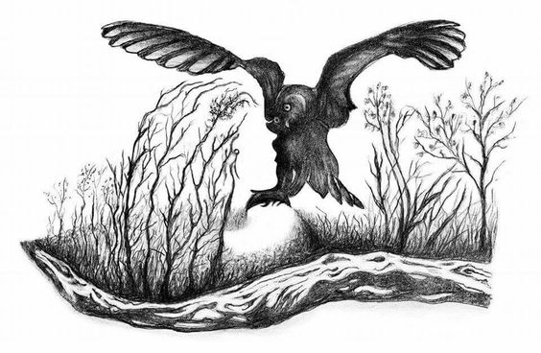

Optical Illusion for IQ Test: Spot hidden face of a Beautiful Woman inside forest with an Owl in 7 Secs!

<https://www.jagranjosh.com/general-knowledge/optical-illusion-iq-test-spot-hidden-face-of-beautiful-women-inside-forest-with-owl-1663670848-1>

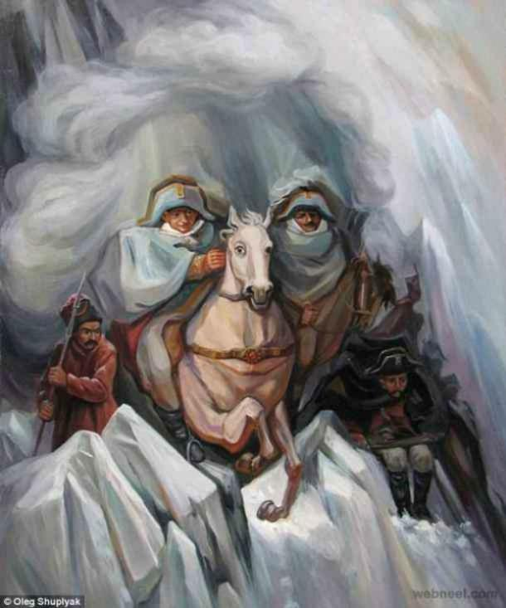

What you see first reveals your secret fear in Romantic Relationship

<https://www.jagranjosh.com/general-knowledge/optical-illusion-love-test-what-you-see-first-reveals-your-secret-fear-in-romantic-relationship-1663339314-1>

**Optical Illusion to Test Your Love Life:**An optical illusion is a mind-bending illustration of an object or a drawing or a picture that has different appearances and can be perceived differently. There are many types of optical illusions like physical, physiological, and cognitive illusions. These optical illusions are sometimes also helpful in testing helpful as our innermost desires and things we don’t usually reveal about ourselves. These are also a part of the field of psychoanalysis as they throw some light on your personality traits. Many optical illusion images can reveal hidden aspects of our personality and our deepest desires based on what we see.  One such fine illustration can be seen in an old optical illusion painting created by artist Oleg Shupliak.

## **What do you see first in this Optical Illusion?**

This optical illusion is kind of a personality test that helps in revealing your secret fear in love. The faces that you can see in this optical illusion are:

1. **A Woman** **- Fear of Losing Sleep in Love**
2. **The Mounted Soldiers** **- Fear to keep up the Appearances in Love**
3. **A Horse** **- Fear of Rejection in Love**
4. **The Soldiers in the Background** **- Fear of Playing Games in Love**

Visual Thinking Logically

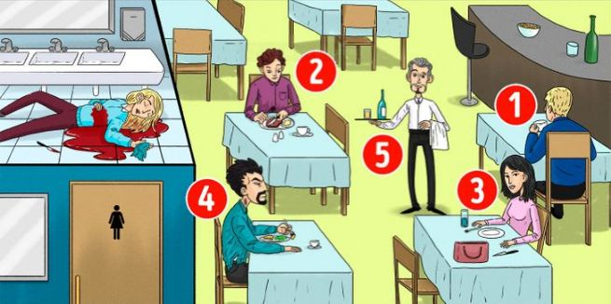

who is the Killer of the woman in the restaurant

<https://www.jagranjosh.com/general-knowledge/brain-teaser-iq-test-who-is-the-killer-of-woman-in-restaurant-picture-1662977945-1>

This IQ test is a fun way to know your Intelligence Quotient.

This brain teaser will help in testing your intelligence level based on the decision you make while looking at the problem. While solving these brain teasers, you need to scan the problem and arrive at the answer by using analytical reasoning skills. Brain puzzles make a simple riddle more interesting, as these fun games are solved with creative thinking. You need to think a little differently for coming on to the solution as the answer won’t be right in front of you. So, we have come up with an interesting brain teaser where you have to identify the Killer among the five people suspected to be the murderer of the woman in the restaurant in the image.

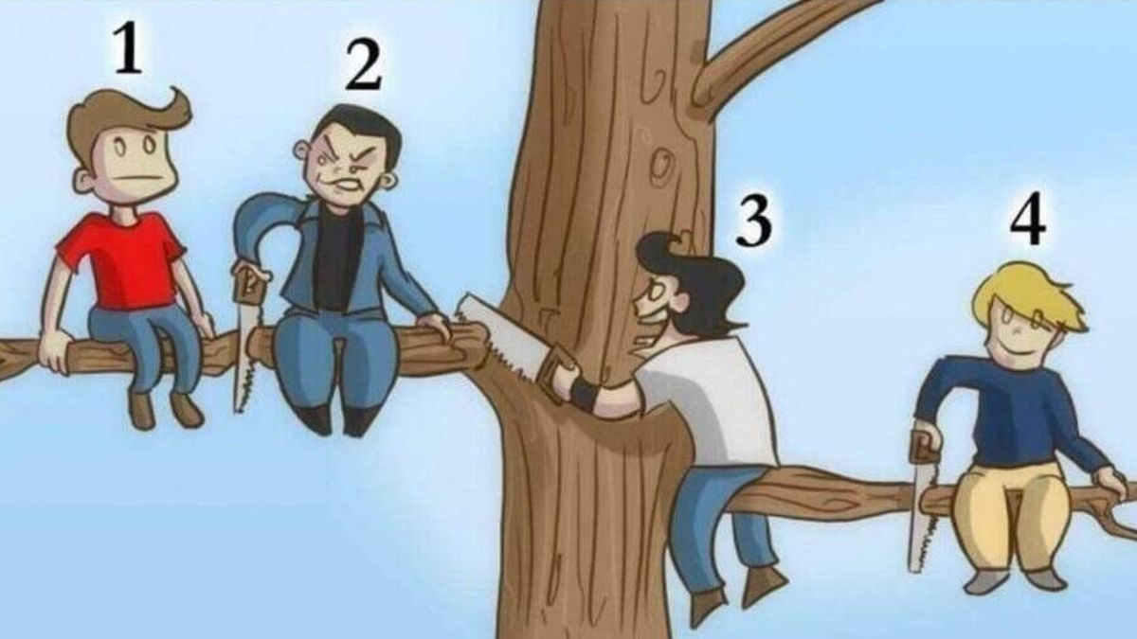

<https://www.jagranjosh.com/general-knowledge/brain-teaser-iq-test-who-is-the-most-stupid-person-in-picture-1662446335-1>

This brain teaser will help in testing your intelligence level based on the decision you make while looking at the problem. This IQ test is also a fun way to know your Intelligence Quotient. Brain puzzles make a simple riddle more interesting, as these fun games are solved with creative thinking. While solving these brain teasers, you need to scan the problem and arrive at the answer by using analytical reasoning skills. You need to use a little different approach for coming on to the solution as the answer won’t be right in front of you. So, we have come up with an interesting brain teaser where you have to identify the most stupid person among the four people sitting on a tree branch in the image.

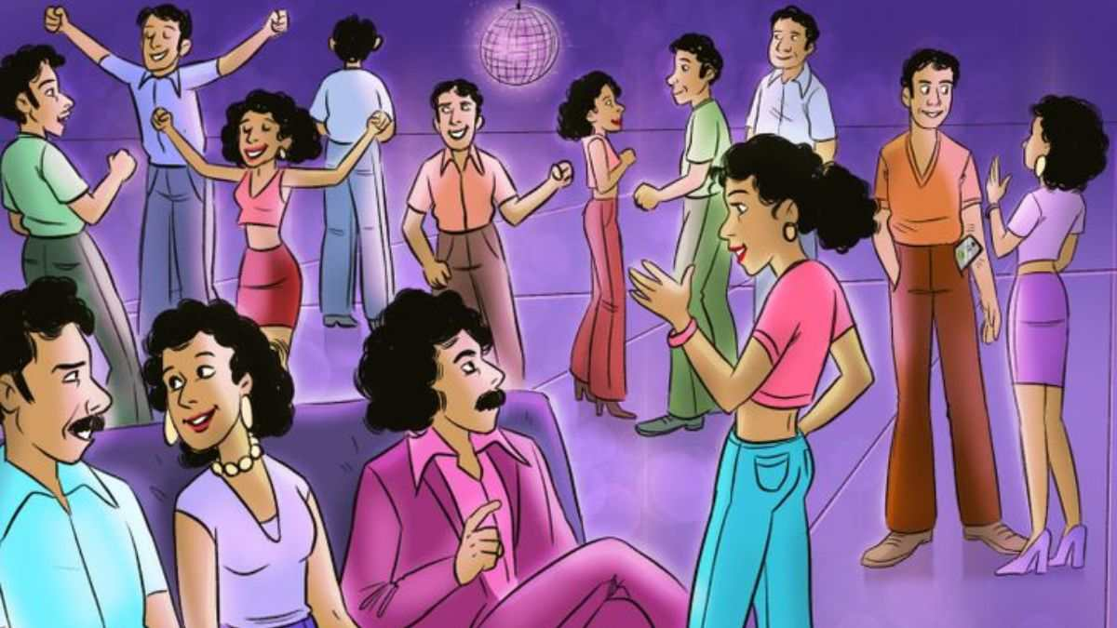

Identify who is from future in 1970s picture

<https://www.jagranjosh.com/general-knowledge/brain-teaser-iq-test-identify-who-is-from-future-in-1970s-picture-1663328461-1>

This IQ test is a fun way to check your Intelligence Level. Some brain teasers will help in assessing your intelligence level based on the decision you make while looking at the problem. The important task in these puzzles is to scan the problem quickly and arrive at the answer by using your logical reasoning skills. Brain teasers make a simple puzzle more interesting, as these fun IQ Tests are solved with creative thinking. You need to out of the box for coming on to the solution as the answer would be hiding somewhere in the picture. So, we have come up with an interesting brain teaser where you have to identify in who is from the future in the 1970s image.



https://www.jagranjosh.com/general-knowledge/optical-illusion-can-you-find-the-giraffe-in-the-forest-within-7-seconds-1671026619-1

**Optical Illusion Test:**Optical illusions are mind-bending images that challenge your perception and test your observation skills. There are three types of optical illusions literal, physiological, and cognitive.

The beauty of optical illusions is how they capture the user's attention for a brief moment.

It also provides good exercise for the brain.

Studies have suggested that regular practice of optical illusions is helpful in improving your concentration and observation skills.

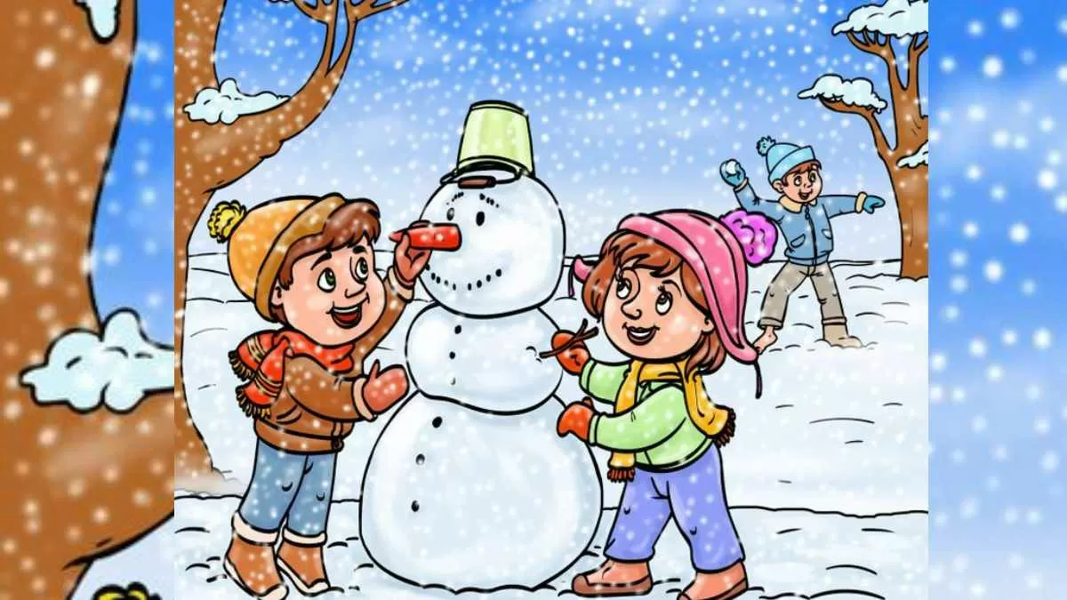

<https://www.jagranjosh.com/general-knowledge/brain-teaser-iq-test-spot-mistake-in-picture-where-kids-are-playing-in-snow-1671105947-1>

**Brain Teaser IQ Test:**If you enjoy solving fun games and puzzles, then this brain teaser is for you! Brain teasers allow you to use the creative side of your mind and make your brain works in a different. This kind of brain puzzle makes a simple riddle more interesting by adding a fun element to it. For arriving at the answer, you need to think outside the box and analyze the puzzle a little differently. So, we have come up with an interesting brain teaser where you have to spot the mistake hidden inside the Picture where kids are playing in the snow.

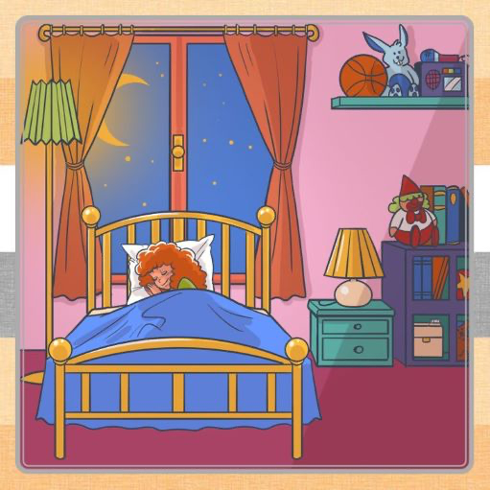

<https://www.jagranjosh.com/general-knowledge/optical-illusion-iq-test-spot-toothbrush-hidden-inside-bedroom-1671013352-1>

**Optical Illusion for IQ Test:**An optical illusion is a mind-bending, deeply fascinating, shape-shifting image of an object or drawing, or people that challenge the brain’s way of perceiving things. You must have seen many types ofoptical illusions like physical, physiological, and cognitive illusions. Studies reveal that optical illusions are also a part of the field of psychoanalysis that throws light on how you perceive things. A normal brain a human can look at things or images differently forming a different perception from each angle.  One such clever illustration can be seen in the image where a Toothbrush is hiding somewhere inside the Bedroom picture.

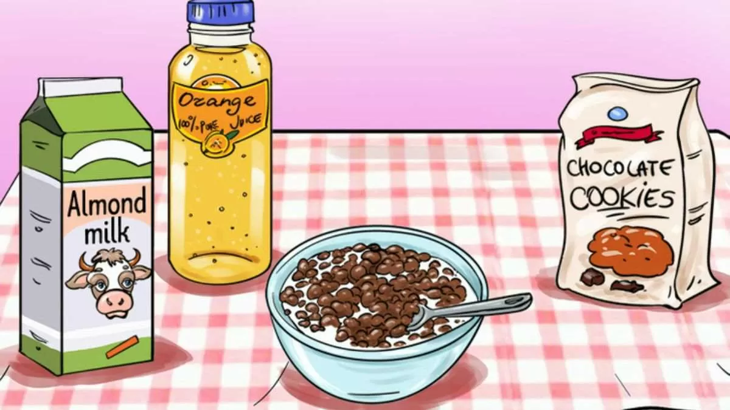

<https://www.jagranjosh.com/general-knowledge/brain-teaser-iq-test-spot-mistake-in-breakfast-table-1671017393-1>

**Brain Teaser for IQ Test:**If you enjoy solving fun quiz and puzzles, then this brain teaser is for you! Brain teasers allow you to use your analytical side and make your brain works in a different way. Such brain quizzes make a simple a puzzle more interesting by adding a fun task to it. For coming onto the solution, you need to think out of the box and analyze the problem little differently. So, we have come up with an interesting brain teaser where you have to spot the mistake hidden inside the Breakfast Table Picture.

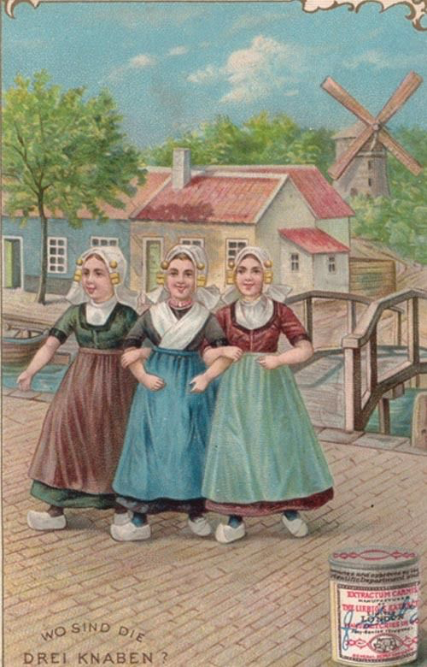

<https://www.jagranjosh.com/general-knowledge/optical-illusions-iq-test-spot-girls-three-hidden-lovers-inside-picture-1671102351-1>

**Optical Illusion IQ Test:**An optical illusion is a mind-bending illustration of an object or a drawing or a picture that has different appearances and can be perceived differently. There are many types of optical illusions like physical, physiological, and cognitive illusions. Many optical illusion images can reveal hidden aspects of our personality and our deepest desires based on what we see. These are also a part of the field of psychoanalysis as they throw some light on your intelligence level.  One such fine illustration can be seen in an old optical illusion painting of three girls and their hidden lovers.

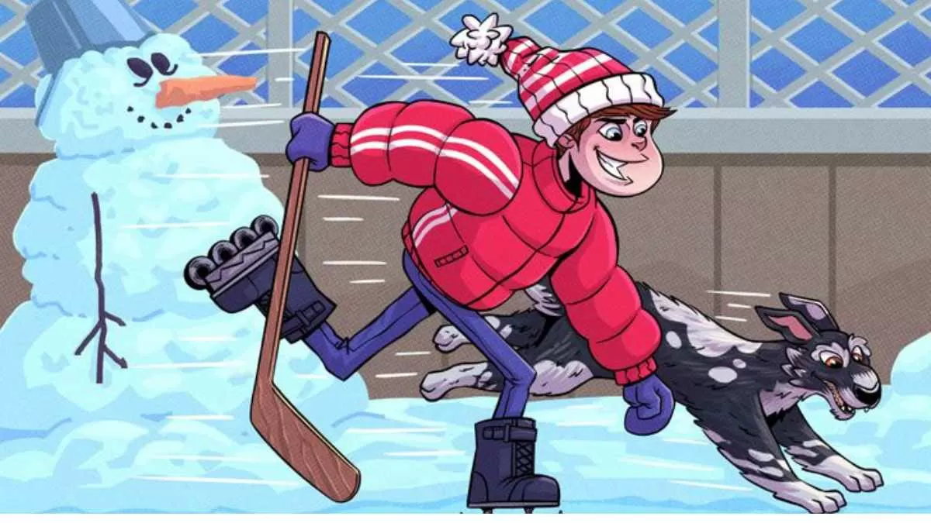

<https://www.jagranjosh.com/general-knowledge/brain-teaser-iq-test-only-3-can-find-what-is-wrong-with-this-ice-skating-picture-in-6-seconds-1671094673-1>

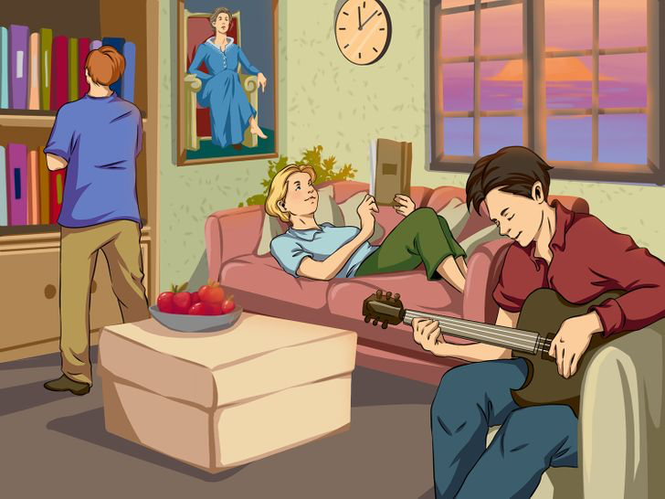

## **Brain Teaser IQ Test: Can you spot 3 mistakes in the Friends' Living Room Picture in 9 seconds?**

<https://www.jagranjosh.com/general-knowledge/brain-teaser-iq-test-spot-3-mistakes-inside-friends-living-room-picture-1673350396-1>

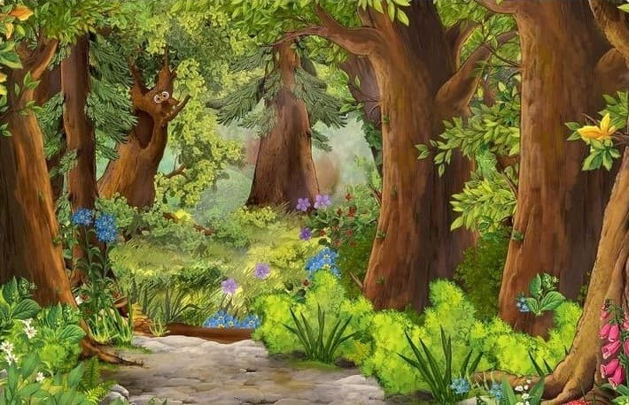

## Optical Illusion - Find Owl in the Forest in 5 Seconds

<https://www.jagranjosh.com/general-knowledge/optical-illusion-you-have-eagle-eyes-if-you-can-find-the-owl-in-the-forest-within-5-seconds-1673263574-1>

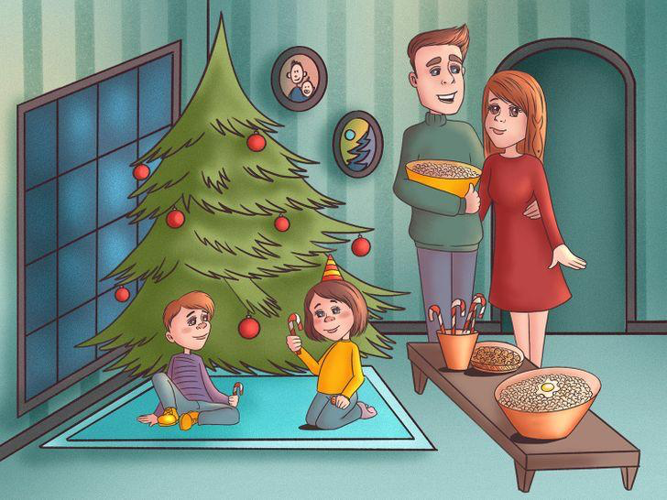

## **Brain Teaser IQ Test: We Bet You Can’t Find The Egg, Glove, And Fish in The Living Room In 7 Secs!**

<https://www.jagranjosh.com/general-knowledge/brain-teaser-iq-test-we-bet-you-cant-find-the-egg-glove-and-fish-in-the-living-room-in-7-secs-1673685213-1>

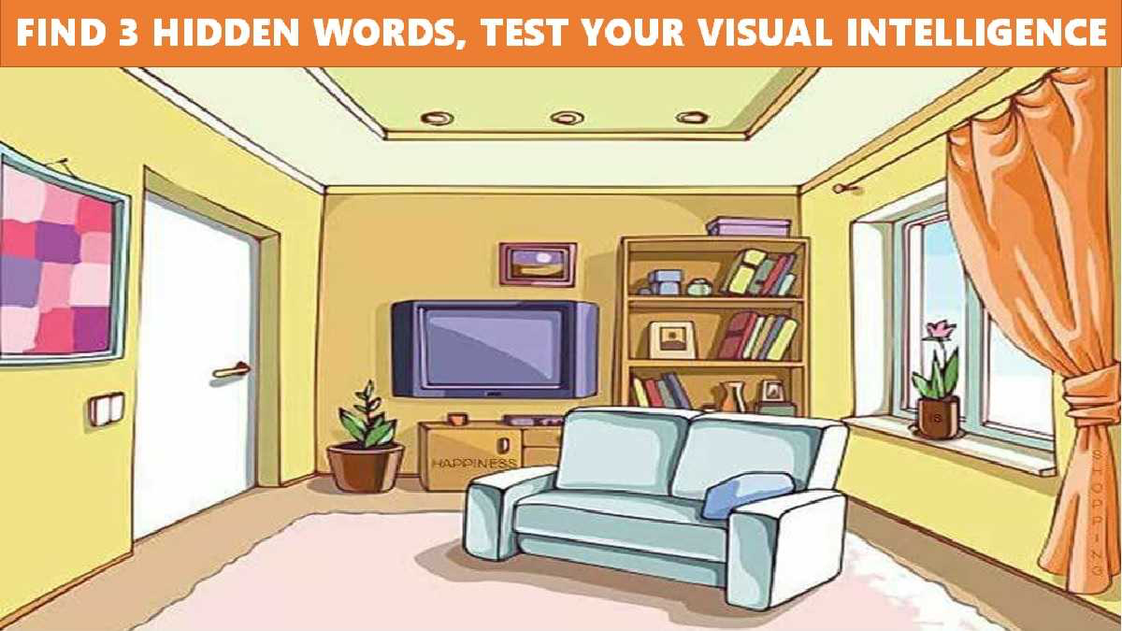

## **Find The Hidden Words In The Picture In 11 Seconds, Test Your IQ**

<https://www.jagranjosh.com/general-knowledge/picture-puzzles-only-1-percent-genius-can-you-find-the-hidden-words-in-this-living-room-1673605775-1>

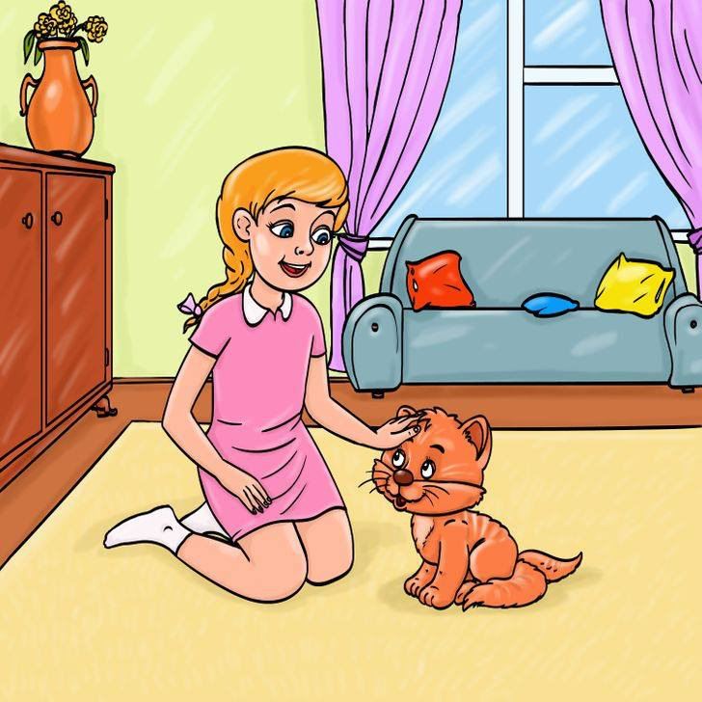

## **Brain Teaser IQ Test: Can you spot the mistake in Girl Petting her Cat Picture within 5 seconds?**

<https://www.jagranjosh.com/general-knowledge/brain-teaser-iq-test-spot-mistake-in-girl-petting-her-cat-picture-1673867581-1?ref=amp_rel_stories>



## Optical Illusion Test - Find Seashell among the Rocks in 5 Seconds

<https://www.jagranjosh.com/general-knowledge/optical-illusion-test-can-you-find-a-seashell-among-the-rocks-in-5-seconds-1673782950-1>



# Optical Illusion for Testing Your IQ: Only 1% can spot Hidden Date inside Family Picnic Picture in 7 secs!

<https://www.jagranjosh.com/general-knowledge/optical-illusion-iq-test-spot-hidden-date-inside-family-picnic-picture-1673346003-1>



## Seek and Find - Find Parrot in 5 Seconds

<https://www.jagranjosh.com/general-knowledge/seek-and-find-can-you-find-a-parrot-in-the-jungle-within-5-seconds-1673613530-1>

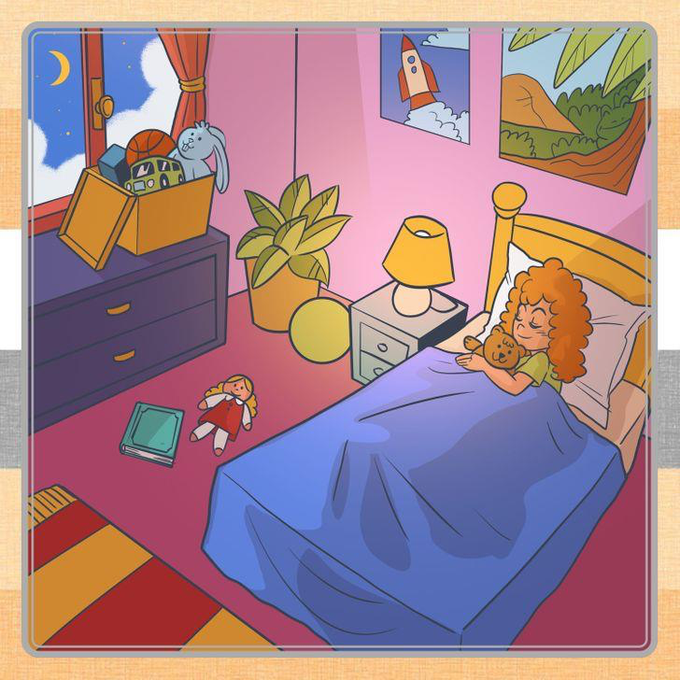

## **Optical Illusion for IQ Test: Only 3% can find Frog hidden inside the Girl’s Bedroom**

<https://www.jagranjosh.com/general-knowledge/optical-illusion-iq-test-find-frog-hidden-inside-girls-bedroom-1673510530-1>

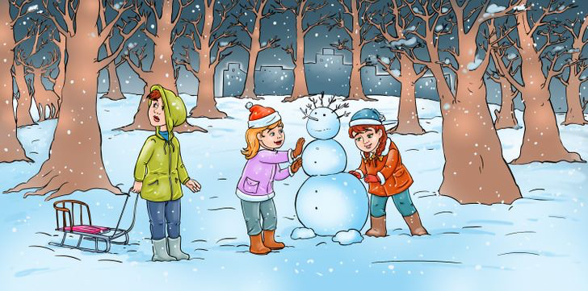

## **Optical Illusion to Test Your IQ: Spot Hidden Deer inside the Snowy Forest!**

<https://www.jagranjosh.com/general-knowledge/optical-illusion-iq-test-spot-hidden-deer-inside-snowy-forest-1673013598-1>

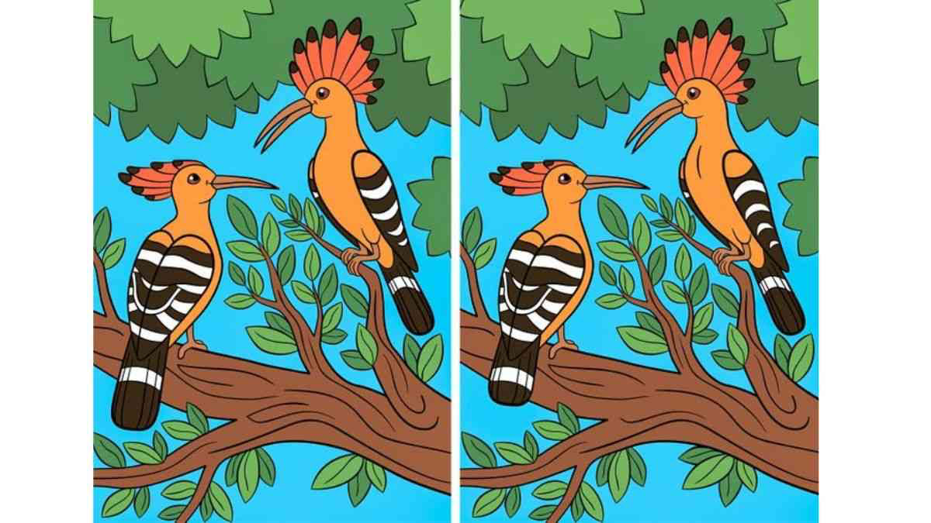

## **Can you spot the differences between the two images of Woodpeckers?**

<https://www.jagranjosh.com/general-knowledge/brain-teaser-can-you-spot-the-5-major-differences-between-the-two-pictures-of-woodpeckers-1672207675-1>

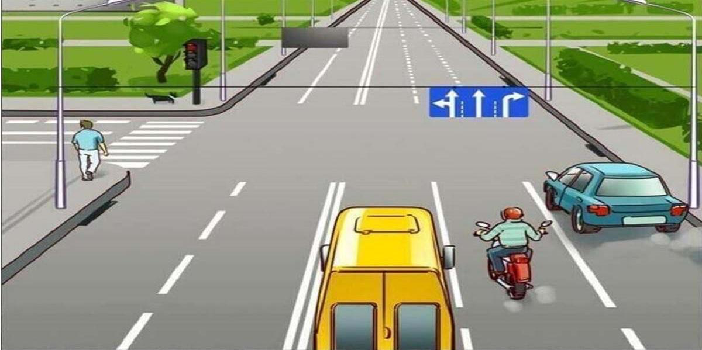

# Picture Puzzle: Find the Mistake In 11 Seconds, High Observational Skills Required

<https://www.jagranjosh.com/general-knowledge/picture-puzzle-find-the-mistake-in-11-seconds-high-observational-skills-required-1672577247-1>

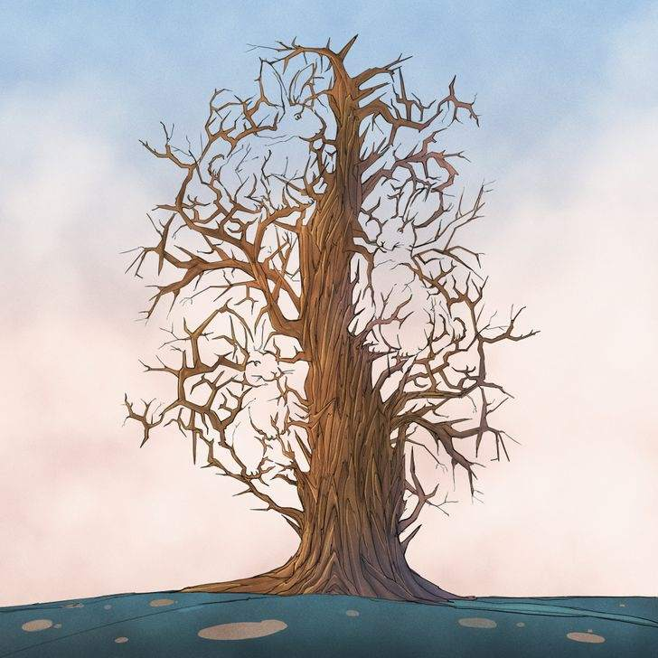

## **Can you spot the 3 Bunnies hidden inside the tree?**

<https://www.jagranjosh.com/general-knowledge/optical-illusion-iq-test-spot-3-bunnies-hidden-inside-tree-1674545613-1>

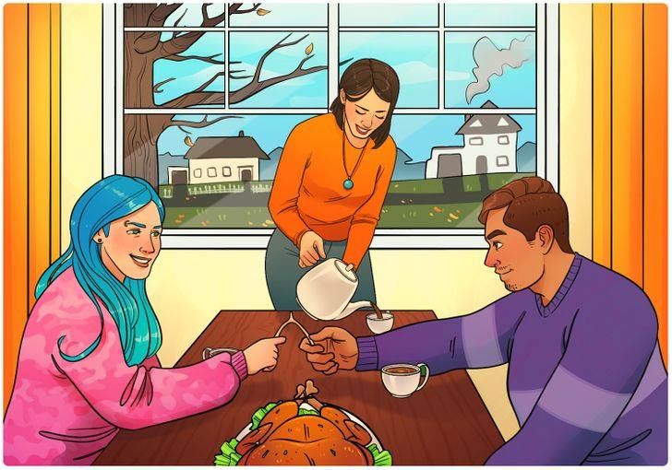

## **Can you spot the mistake in the Friends Supper Picture within 9 seconds?**

<https://www.jagranjosh.com/general-knowledge/brain-teaser-iq-test-spot-mistake-in-friends-supper-picture-1674548433-1?ref=amp_rel_stories>



## **Find the Cat among the Houses in 5 Seconds**

<https://www.jagranjosh.com/general-knowledge/optical-illusion-challenge-can-you-find-a-cat-among-the-houses-in-5-seconds-1674562022-1?ref=amp_rel_stories>

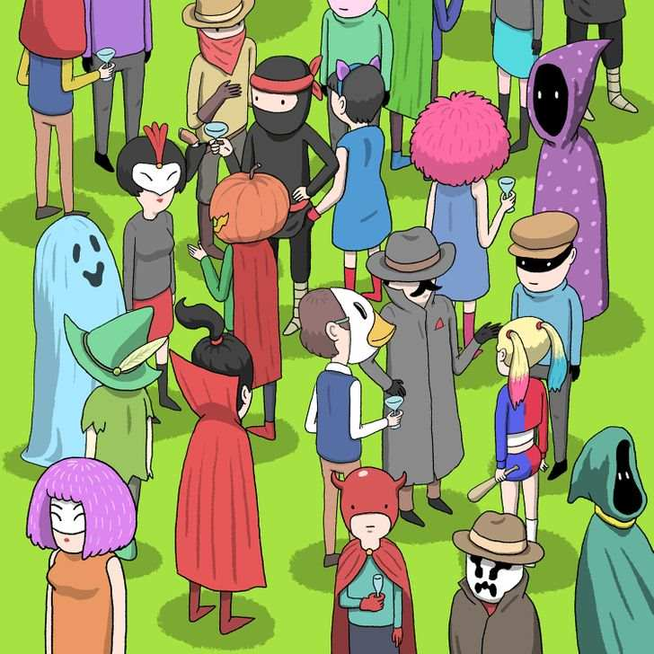

## **Can you Spot a Thief in the Costume Party within 11 seconds?**

<https://www.jagranjosh.com/general-knowledge/brain-teaser-iq-test-can-you-spot-thief-in-costume-party-picture-1674470698-1?ref=amp_rel_stories>

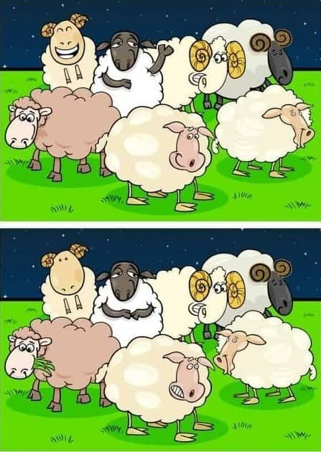

## Spot 5 Differences in 19 Seconds

<https://www.jagranjosh.com/general-knowledge/spot-the-difference-can-you-spot-5-differences-within-19-seconds-1674472911-1?ref=amp_rel_stories>

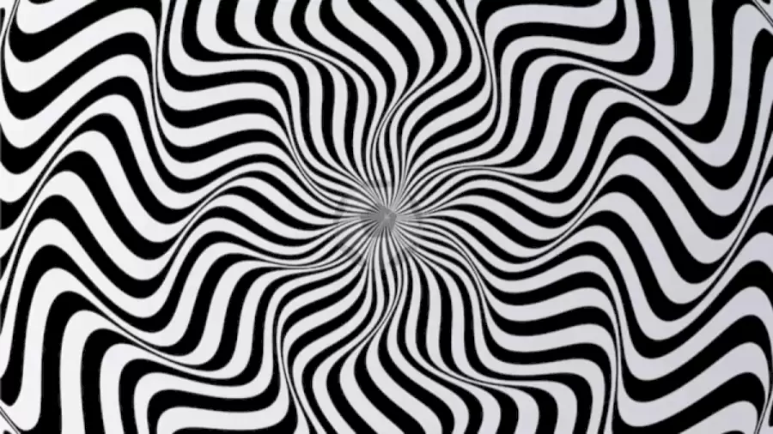

# Try To Guess the Hidden Object in this Optical Illusion

# <https://www.fresherslive.com/latest/articles/want-to-test-your-vision-try-to-guess-the-hidden-object-in-this-optical-illusion-10006033>

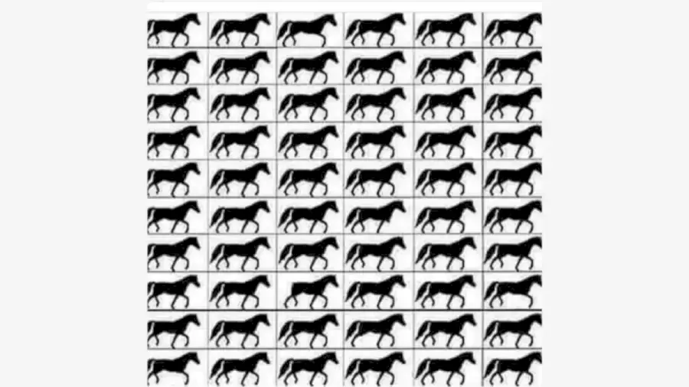

# How Many Horses with 3 Legs?

<https://www.fresherslive.com/latest/articles/how-good-are-your-eyes-find-out-brain-teaser-puzzle-how-many-horses-with-3-legs-10003729>

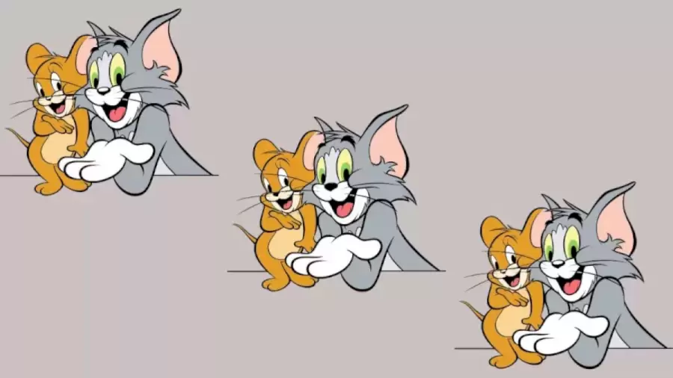

# Which Of These Picture Is Different?

<https://www.fresherslive.com/latest/articles/brain-teaser-which-of-these-picture-is-different-visual-eye-test-10003593>

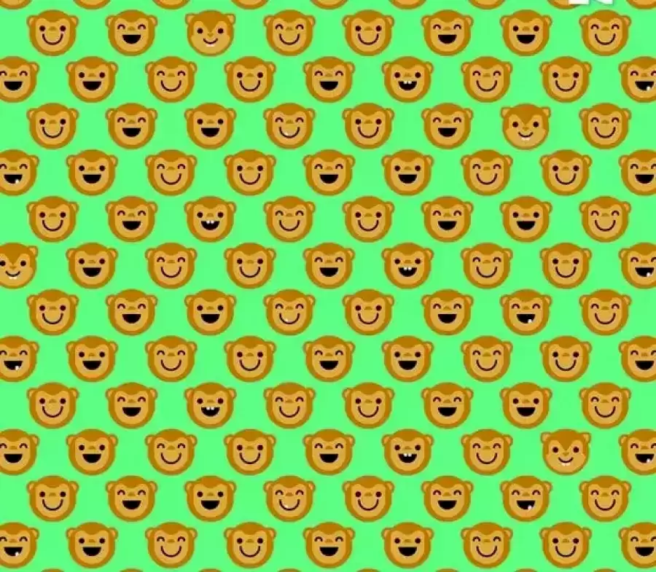

# Can You Find The 4 Squirrels Among The Monkeys Within 18 Secs?

# <https://www.fresherslive.com/latest/articles/can-you-find-the-4-squirrels-among-the-monkeys-within-18-secs-only-a-few-can-get-it-explanation-and-solution-to-the-squirrels-optical-illusion-10003299>

# 

# Can You Spot the Hidden Dog in 8 Seconds?

# <https://www.fresherslive.com/latest/articles/optical-illusion-visual-challenge-can-you-spot-the-hidden-dog-in-8-seconds-10002395>

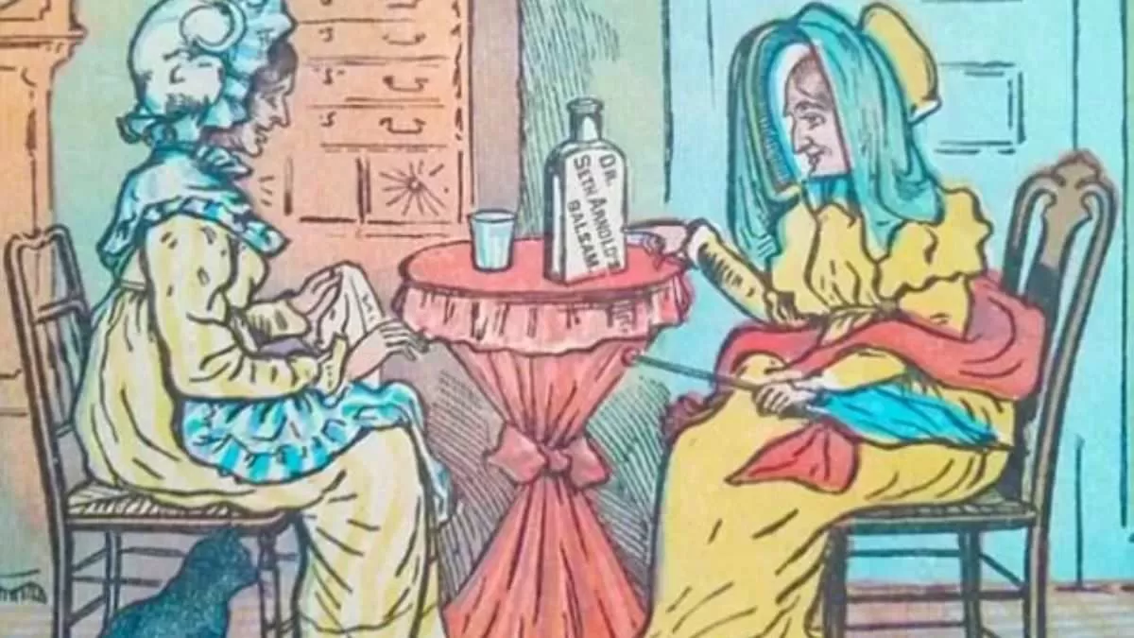

# Only 1% can spot second cat hiding inside Vintage Picture in 15 secs!

<https://www.jagranjosh.com/general-knowledge/optical-illusion-iq-test-spot-second-cat-inside-vintage-picture-1675758475-1>

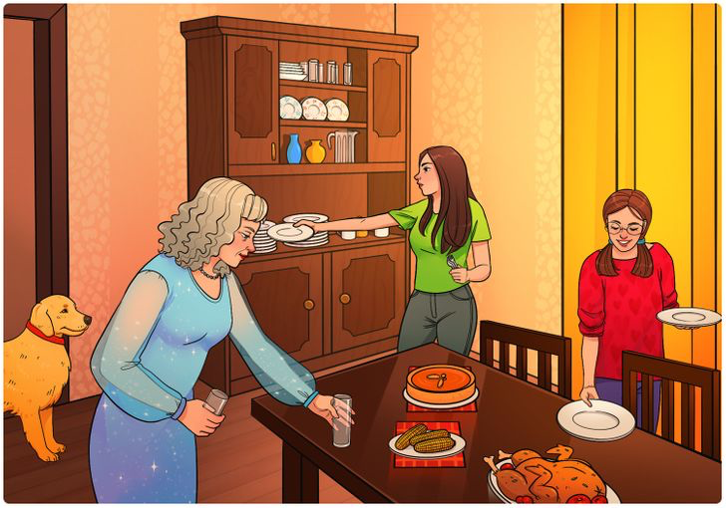

## **Can you spot the mistake in the Dining Room Picture in 11 seconds?**

<https://www.jagranjosh.com/general-knowledge/brain-teaser-iq-test-can-you-spot-mistake-in-dining-room-picture-1675852232-1?ref=amp_rel_stories>

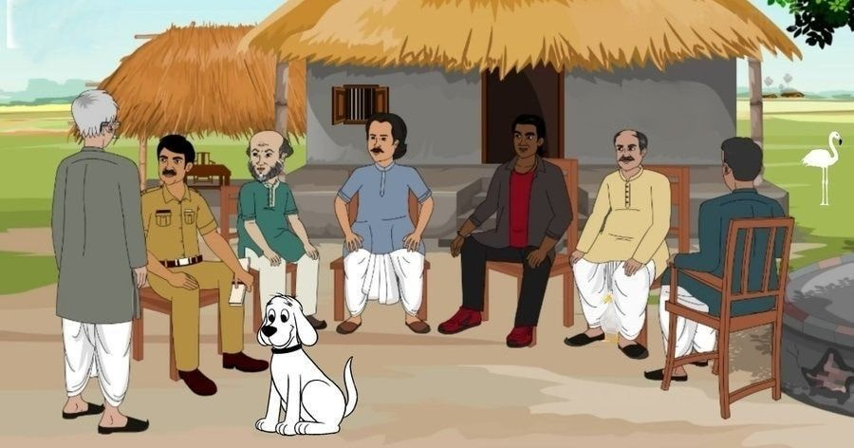

## Find the Hidden Duck in 6 Seconds

<https://www.jagranjosh.com/general-knowledge/optical-illusion-you-have-hawk-eyes-if-you-can-spot-a-duck-in-the-image-in-6-seconds-1675835074-1>

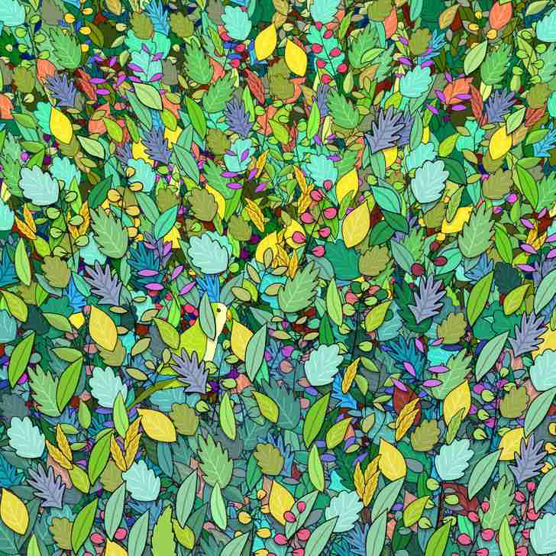

## **Can you spot the Hidden Bird Between the Leaves?**

<https://www.jagranjosh.com/general-knowledge/optical-illusion-iq-test-spot-hidden-bird-between-leaves-1675928984-1?ref=amp_rel_stories>

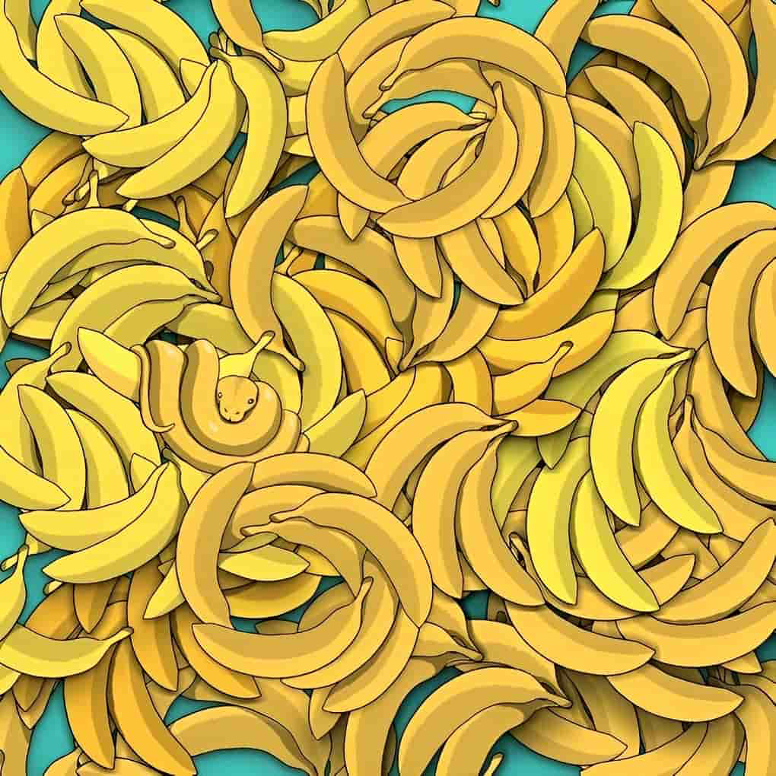

## Find the Hidden Snake in 5 Seconds

<https://www.jagranjosh.com/general-knowledge/optical-illusion-challenge-you-are-a-champion-if-you-can-spot-a-snake-in-5-seconds-1675946749-1>

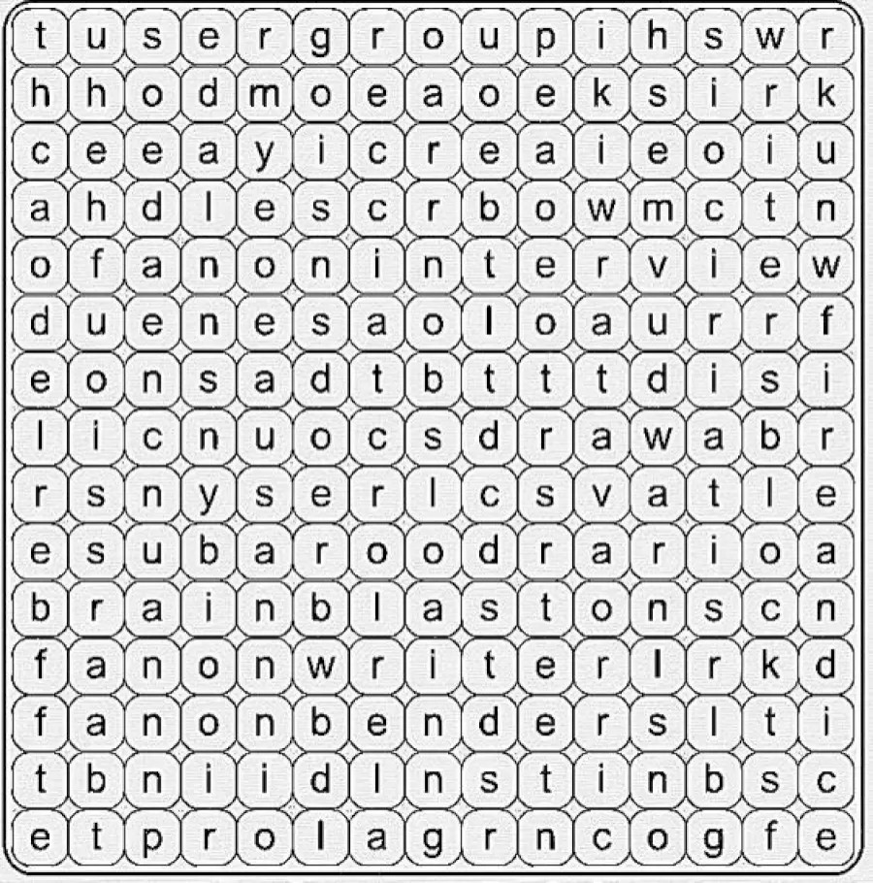

# Brain Teaser Eye Test: Can You Find the Word *Fire and Ice* within 20 Seconds?

# <https://www.fresherslive.com/latest/articles/brain-teaser-eye-test-can-you-find-the-word-fire-and-ice-within-20-seconds-10015564>

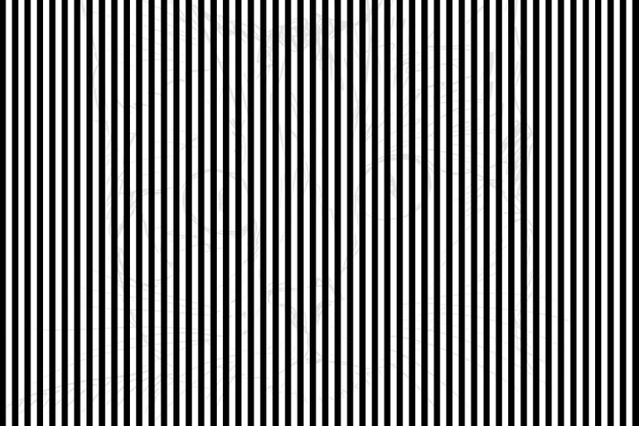

# Optical Illusions for Testing Your IQ: Can you spot the hidden Cat behind horizontal lines in 11 secs?

# <https://www.jagranjosh.com/general-knowledge/optical-illusions-iq-test-can-you-spot-hidden-cat-behind-horizontal-lines-1677842089-1>

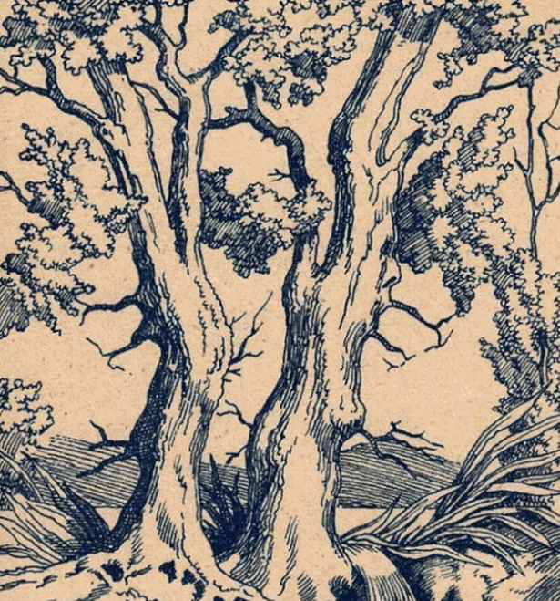

## **Spot the hidden faces of 2 Greek Gods & 1 Human inside the Vintage Picture**

<https://www.jagranjosh.com/general-knowledge/optical-illusion-iq-test-spot-hidden-faces-of-2-greek-gods-1-human-in-vintage-picture-1675945354-1?ref=amp_rel_stories>

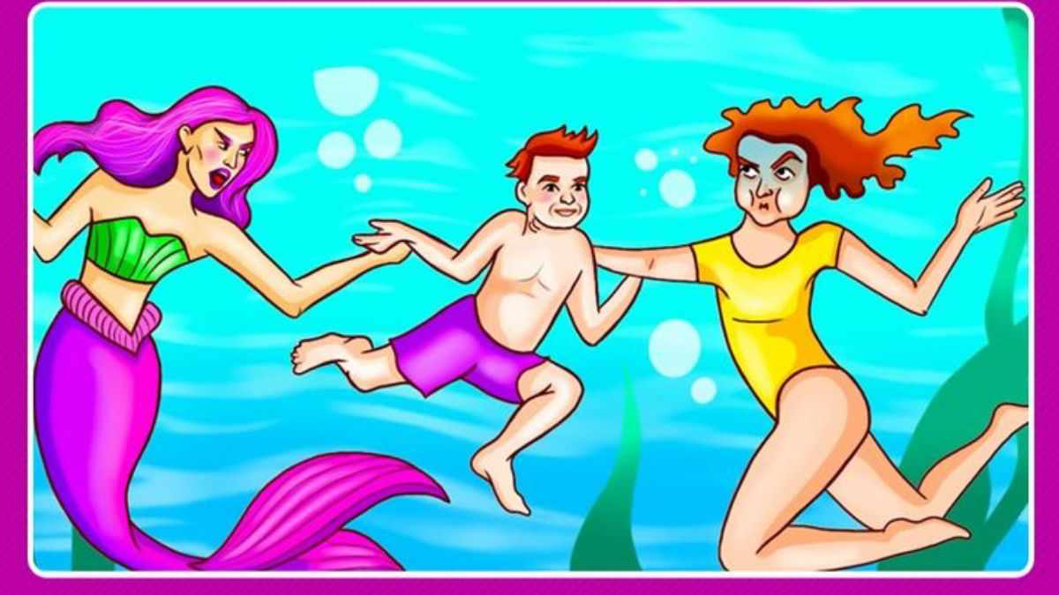

# Can you guess who is the Real Mother of the Boy in Purple Shorts within 7 seconds?

<https://www.jagranjosh.com/general-knowledge/brain-teaser-for-fun-can-you-guess-who-is-the-real-mother-of-the-boy-in-purple-shorts-within-7-seconds-1675770737-1?ref=amp_rel_stories>

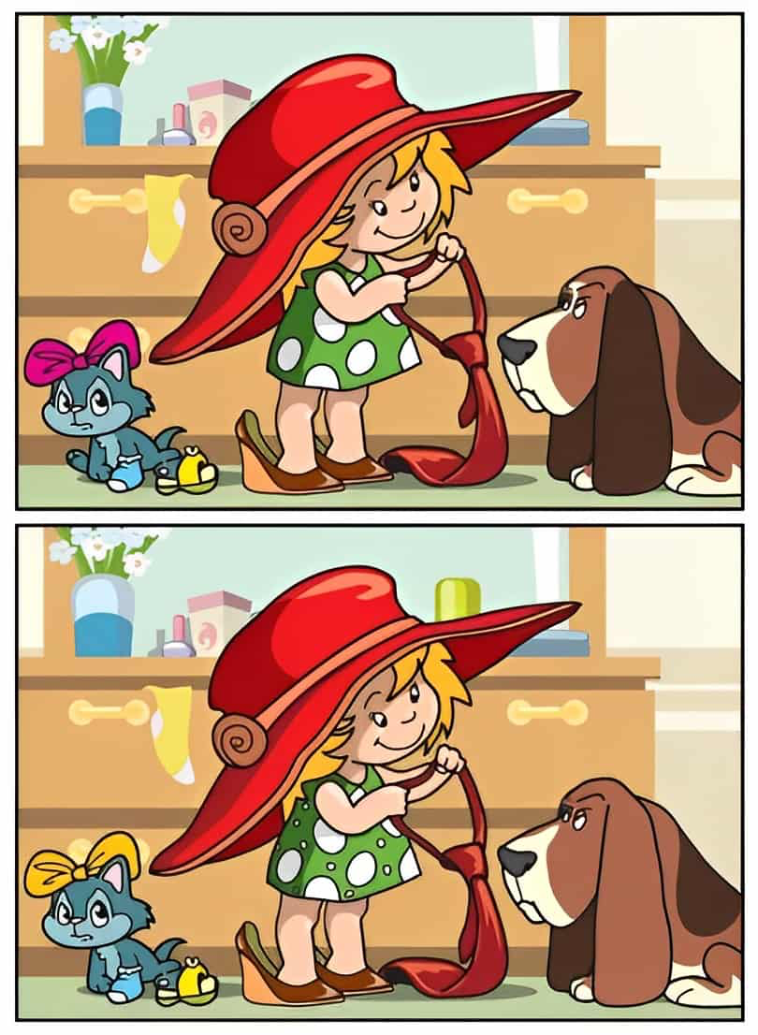

## Spot 10 Differences in 39 Seconds

<https://www.jagranjosh.com/general-knowledge/spot-the-difference-can-you-spot-10-differences-between-the-two-images-in-39-seconds-1675949012-1?ref=amp_rel_stories>

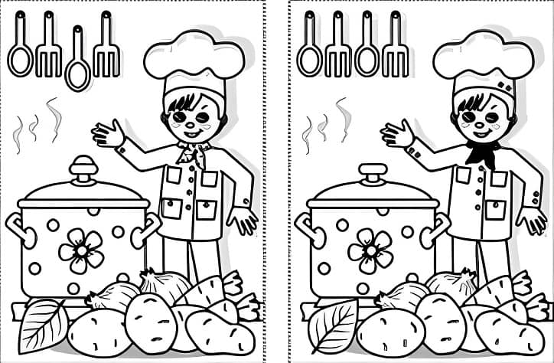

## Spot 10 Differences in 44 Seconds

<https://www.jagranjosh.com/general-knowledge/spot-the-difference-can-you-spot-10-differences-between-the-two-images-in-44-seconds-1675856870-1?usqp=mq331AQGsAEggAID&amp_kit=1>

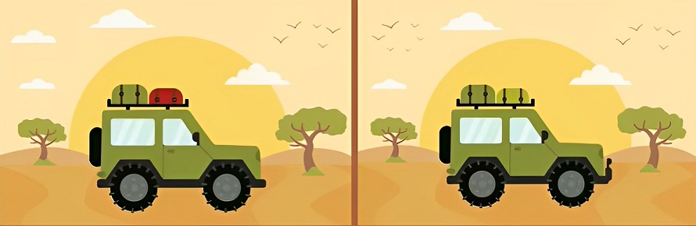

## Spot 5 Differences in 11 Seconds

<https://www.jagranjosh.com/general-knowledge/spot-the-difference-can-you-spot-5-differences-between-the-two-images-in-11-seconds-1675774488-1?ref=amp_rel_stories>

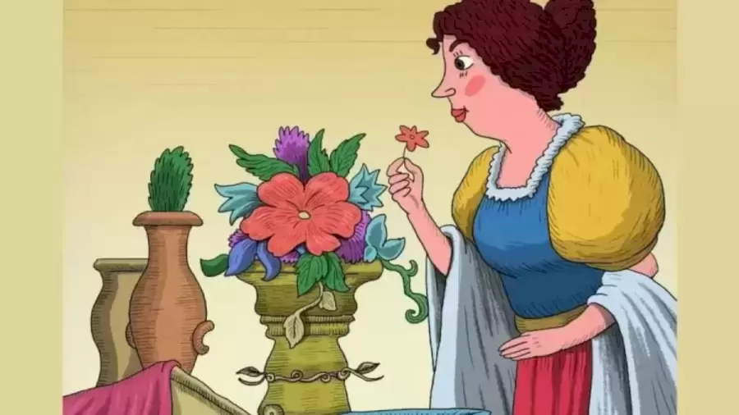

# There are Two Guests Waiting to Meet the Woman. Can You Spot them in 10 Seconds?

<https://www.fresherslive.com/latest/articles/optical-illusion-to-test-your-iq-there-are-two-guests-waiting-to-meet-the-woman-can-you-spot-them-in-10-seconds-10007320>

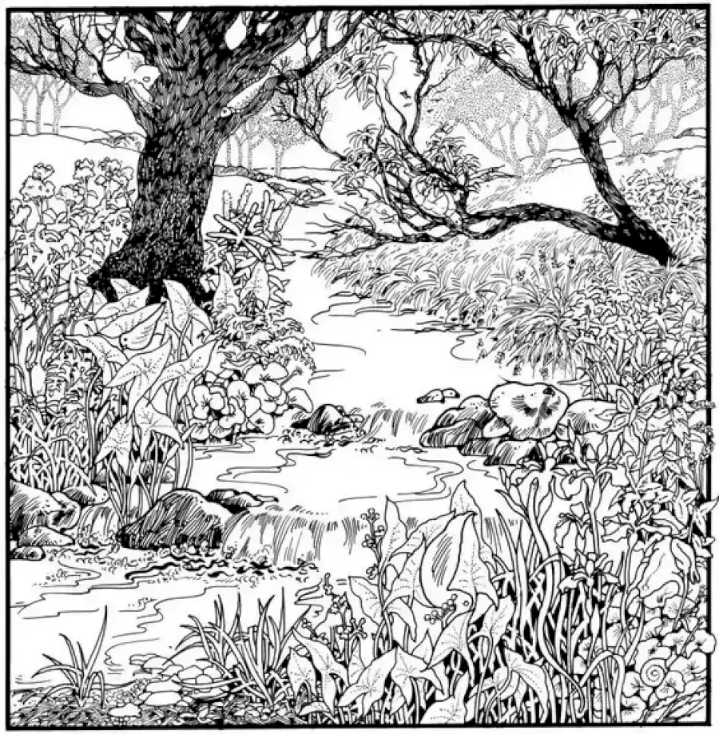

# Can You Find The Rabbit Within 12 Seconds?

<https://www.fresherslive.com/latest/articles/can-you-find-the-rabbit-within-12-seconds-explanation-and-solution-to-the-optical-illusion-10004403>

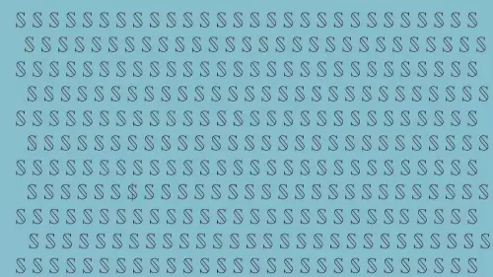

# Optical Illusion: Can You Find $ Among The S In 20 Secs? Explanation And Solution To The Optical Illusion

# <https://www.fresherslive.com/latest/articles/optical-illusion-can-you-find-among-the-s-in-20-secs-explanation-and-solution-to-the-optical-illusion-10006397>

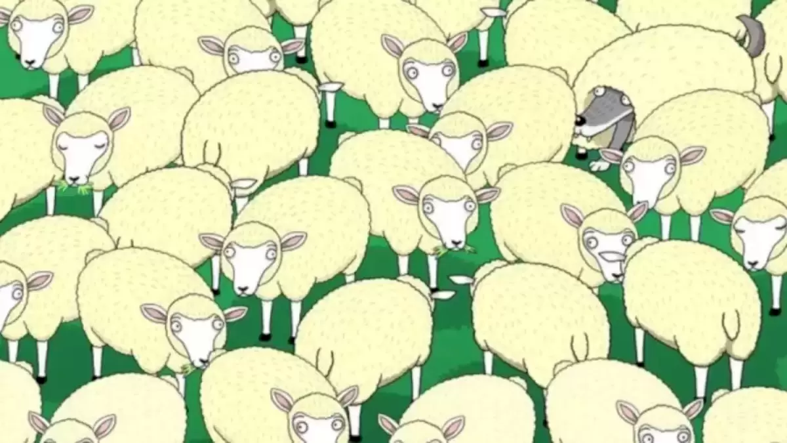

# Can You Spot The Wolf In The Sheep Within 10 Secs?

<https://www.fresherslive.com/latest/articles/can-you-spot-the-wolf-in-the-sheep-within-10-secs-explanation-and-solution-to-the-hidden-wolf-optical-illusion-10007951>



## **Optical Illusion for IQ Test:  Can you spot the hidden animal behind the Zigzag lines?**

<https://www.jagranjosh.com/general-knowledge/optical-illusion-iq-test-spot-hidden-animal-behind-zigzag-lines-1675670560-1>

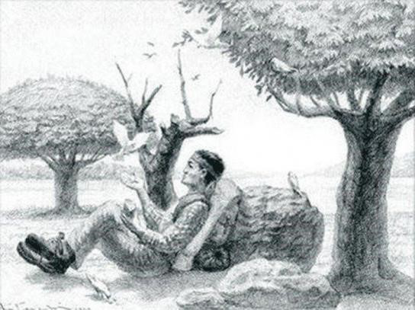

## **Optical Illusion for IQ Test: Only 2% can spot the hidden horse of the man in this Vintage Picture**

<https://www.jagranjosh.com/general-knowledge/optical-illusion-iq-test-spot-hidden-horse-of-the-man-inside-vintage-picture-1675152168-1>

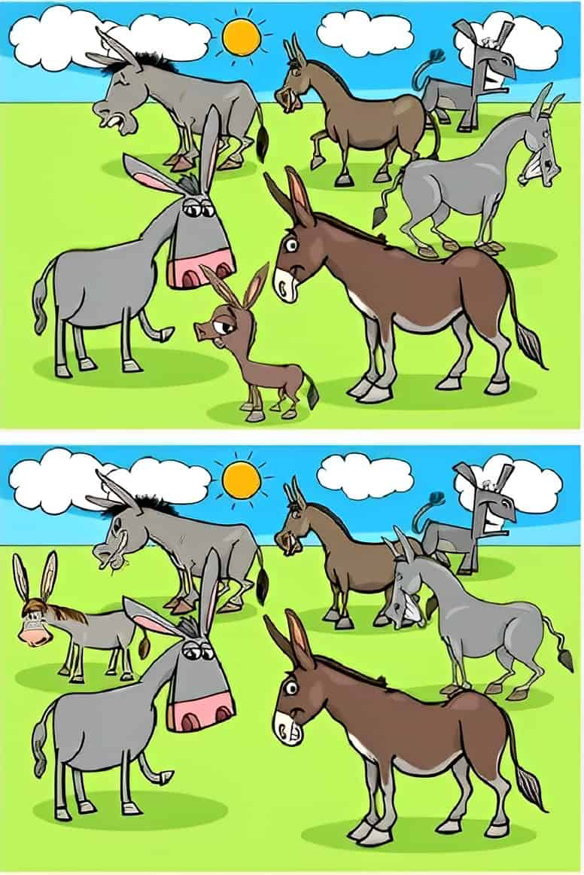

# Spot The Difference: Can You spot 6 differences between the two images in 14 seconds?

<https://www.jagranjosh.com/general-knowledge/spot-the-difference-can-you-spot-6-differences-between-the-two-images-in-14-seconds-1676283276-1>

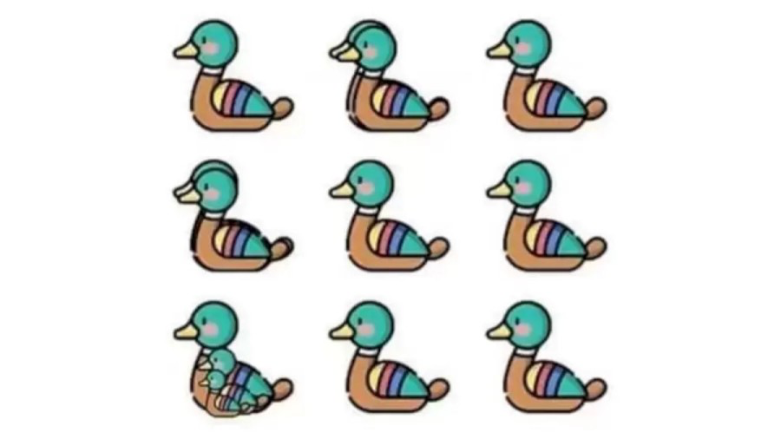

# Want To Know How Good Your Eyesight Is? Try to Guess The Number Of Ducks In This Optical Illusion

<https://www.fresherslive.com/latest/articles/want-to-know-how-good-your-eyesight-is-try-guess-the-number-of-ducks-in-this-optical-illusion-10009780>

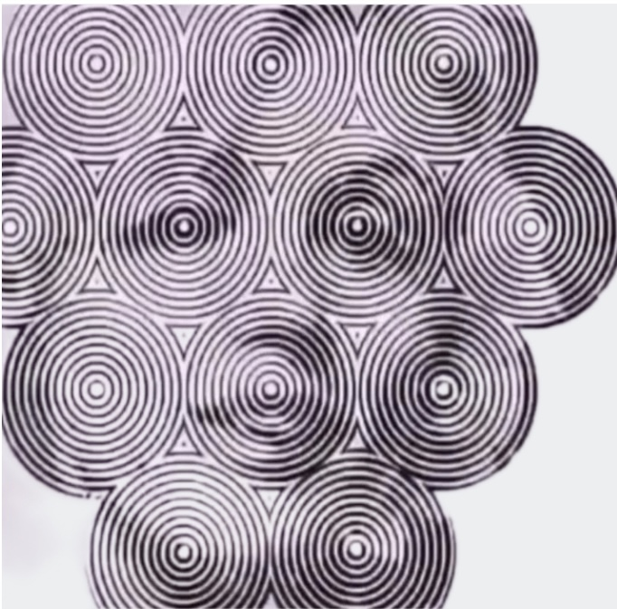

Optical Illusion: can you see the face in 5 seconds?

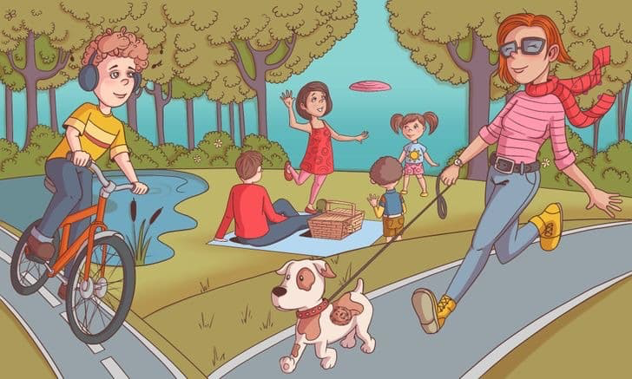

## Optical Illusion Challenge - Find the Hippo in 8 Seconds

<https://www.jagranjosh.com/general-knowledge/optical-illusion-challenge-can-you-spot-the-hidden-hippo-in-the-image-in-8-seconds-1676635296-1>

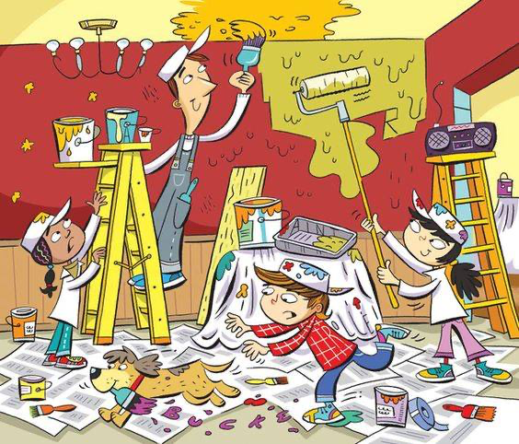

## **Brain Teaser to Test Your IQ: Can you spot all 6 words hidden in the Painting Picture within 15 secs?**

https://www.jagranjosh.com/general-knowledge/brain-teaser-iq-test-spot-6-hidden-words-in-painting-picture-1676450412-1

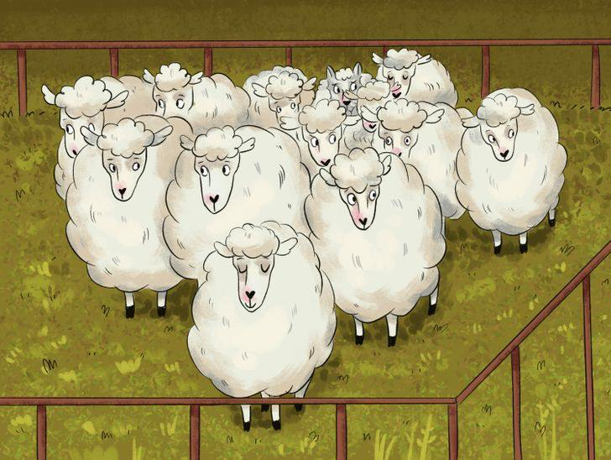

## **Optical Illusion for IQ Test: Can you spot the Hidden Wolf among the Group of Sheep?**

<https://www.jagranjosh.com/general-knowledge/optical-illusion-iq-test-spot-hidden-wolf-among-group-of-sheep-1676533147-1>

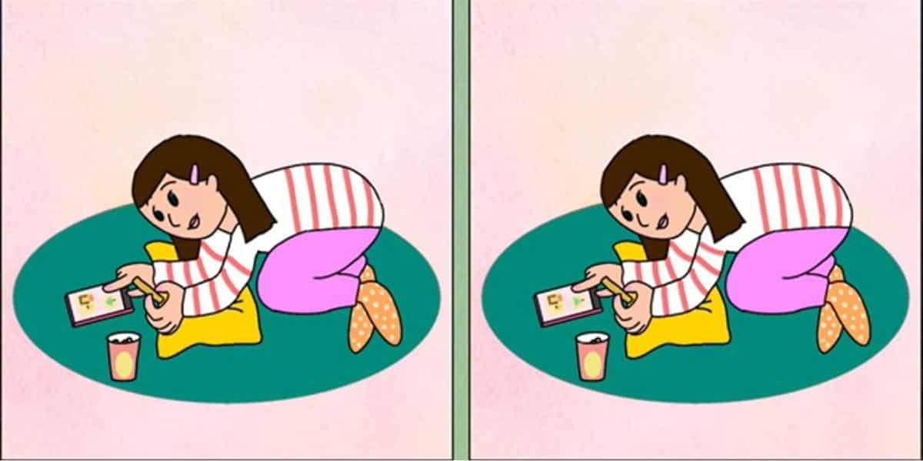

# Spot the difference: Challenge yourself to find the 3 differences – Only 20% complete in under 40 seconds!

# <https://abmeyerwood.com/spot-the-difference-challenge-yourself-to-find-the-3-differences-only-20-complete-in-under-40-seconds/>

# 

# 1880s Vintage Optical Illusion Test: Only a Genius can spot the Dog hidden inside Deer’s Sketch in 11 Secs!

# <https://www.jagranjosh.com/general-knowledge/1880s-optical-illusion-test-spot-dog-hidden-inside-deers-vintage-sketch-1677746940-1>

# 

# Personality test: The animal you see first tells us if you are utopian or realistic

<https://abmeyerwood.com/personality-test-the-animal-you-see-first-tells-us-if-you-are-utopian-or-realistic/>



## **Optical Illusion to Test Your IQ: Spot Hidden Newspaper inside the Public Park!**

<https://www.jagranjosh.com/general-knowledge/optical-illusion-iq-test-only-a-genius-can-spot-hidden-newspaper-inside-public-park-1678341639-1>

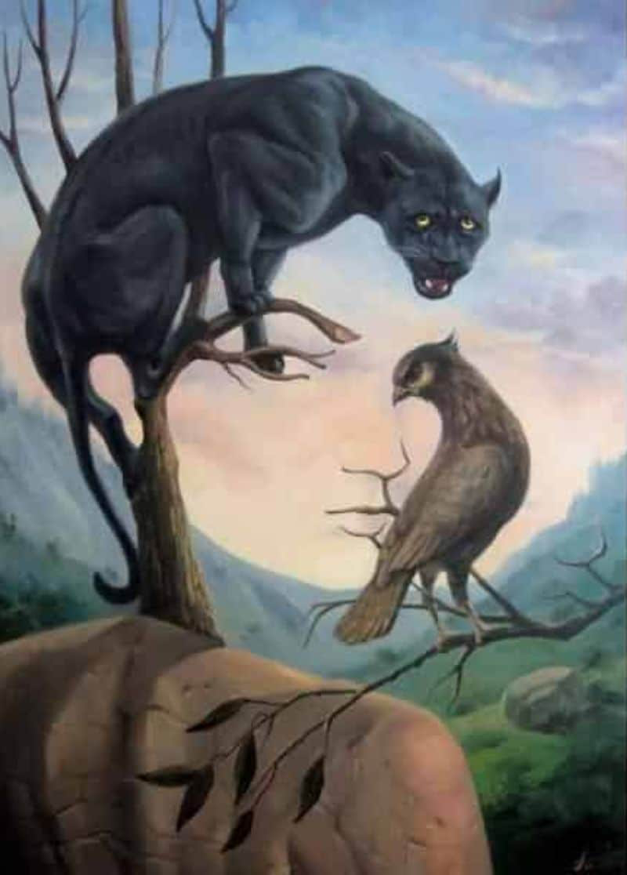

**Personality test: What you see first reveals your level of self-confidence. Do you trust yourself?**

<https://abmeyerwood.com/personality-test-what-you-see-first-reveals-your-level-of-self-confidence-do-you-trust-yourself/>